Criminal justice issues in Texas
Name
Institutional affiliation
Course
Date

Introduction
The world's countries have a body called the criminal justice system whose purpose to focus on delivering justice to everybody. To accomplish this purpose, it convicts and punishes the guilty aiming at helping them stop committing an offence, and this facilitates the protection of innocent (Richard, 2018). The criminal justice system, especially in Texas, helps in detecting different issues, crimes to bring justice, and this is only possible if it has carried out court orders. The lawmakers in Texas need to consider the increasing issues of criminal justice issues in the legislative session of this year. In reality, when we look at Austin, which the capital city of Texas, we cannot deny the fact that reforms of criminal justice have turned to be bipartisan. Texas, criminal justice system, carries the blame for increasingly rising issues like bail reform, reform within Texas state Jail, increase cost in criminal Justice, Civil asset forfeiture and imprisonment of parents that need to be considered by lawmakers of Texas.
The first issue in the Texas criminal justice system that needs to be looked is the Bail reform in its criminal justice system. Recently, advocates have reported that Texas has a broken bail system whereby around 10,000 people get stuck in jail. Jailing here does not depend on how the victims cause risk to societal safety but because they cannot afford the cash for making a bill. Sometimes there is no bail bondsman who can help them get out of jail. Within the political spectrum in Texas, peoples like governors, legislative leaders and top judges report that they are going to prioritize the re-arrangement of how pretrial incarceration operates in this state. This will otherwise lead to the betterment of in identification of people who potentially cause risks to the safety of the majority public. Such an action will give some light on who should be jailed and ensuring there is no unnecessary holding of people in jails.
Christopher (2019) reports what the Director of the Centre for effective justice said in one of the legislative session. "We need better products that are at risk rather than considering if someone has five hundred dollars in the pocket". Most people were jailed, in 1980s as they could be convicted for an offence or crime, and seen as a punishment, but now, currently, that is not true (Christopher, 2019). Sometimes we have people in Texas being arrested and remain not convicted reason being they have no money to the released out of jail. This issue poses a cost to taxpayers amounting to one billion dollars every year, making lawsuits in Texas counties such as Dallas as well as Harris. The Analyst of the criminal justice policy, Nick Hudson has also supposed that the broken bail reform makes most of Texas residents lose families, housing and jobs in the entire Texas communities.
The communities which are over.-policed lose a tremendous amount of money to pay such unnecessary bails. Sensibly, we still have different effective means to get detainee back for trials. Money bail has been entirely banned in some states like California and New Jersey and stands to be typical examples of Bondsmen for bails in different parts of Texas and as such, preparing Texas to fight against this frustrating bail reform. However, Texas's advocates say that a complete ban of cash bail in Texas is not going to be possible. I think it will be best for this system to impose release low-risk arrestee for free (Ortiz, 2019).
The second issue in the Texas criminal justice is Jail Reform within the state. This issue is a priority for liberal and conservative criminal justice reform to advocate for overhauling jail system in Texas. The Texas Public policy foundation Director, Cohen, as argued by Christopher (2019) supports that, in Texas, there are seventeen states. These states were established in 1990s as an imprisonment middle tier between county jails and other prisons in the state the intention of which was to offer Super dosage of training and to treat who are fond of committing crimes related to drugs. At that time, there was a problem since it was not funded, and thus, the jail system was made a short-term warehouse to those who committed drug crimes or offences. Of late, the state jail has had a high rate of recidivism compared to county jails and state prison. As evident in 2013, at least half of the detainees who were released from Texas state jail got convicted within three years for having done another crime, and this prove for the need of state jail reforms by the Texas criminal justice system. It has reached a point whereby, Taxpayers spend at least one hundred and sixty-five million in such state jails, so it means a lot of money is being thrown into state jail system that has been failing in addressing criminal cases such as disorder related to abuse of drug substance. From1990s says Christopher (2019), there have been many offences that can be extracted from state jail felonies list besides offences linked to addiction. It reveals to us that, state jail reform need to consider so that reformers can put improve rehabilitation related programs within the state jails. Also, those making laws should find qualification for state jail felony. See the figure below.
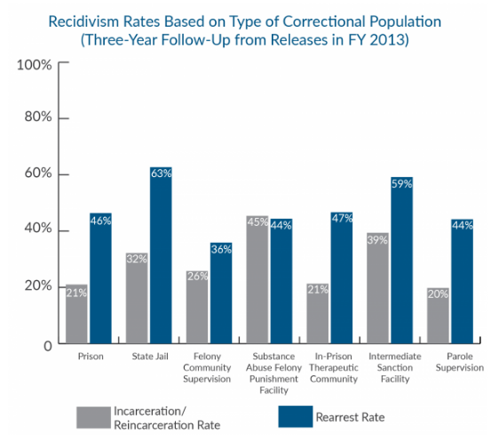
The third issue in the criminal justice system is the costs of criminal justice. Christopher (2019) argues that Merger Mary has tried to direct different illegal projects in Texas. She has put priorities that focus on reduction of the way Texas criminal justice cost lead people into poverty that makes majority very vulnerable. It is reported that surcharges, fines and fines if not paid people are left subjected to solid penalties besides during that one I detained in jail. The criminal justice system has been punishing individuals for having little funds, and as such, such individuals get trapped in poverty and debts cycle.
Christopher (2019) argues that when Texas criminal justice system held the last legislative session, legislation was passed by lawmakers as a way of cutting the number of people jailed for failing to offer criminal justice costs. This issue resulted in a revenue increase in courts. There were few who were reported to have been issue arrest warrant following a default in paying such costs. Also, a decrease in the number of some individual being looked up for not paying fees and fines. Sad in enough last years (2018) almost 500,000 Texans stayed in jail for long following the failure to fulfill criminal justice debt. In most cases, if offender like Texas driver fails to pay fees or even miss to report to the court on time, the renewal of the license is blocked or license itself suspended for some days.
The fourth issue in Texas criminal justice is about parents who are prisoned. Texas has a rising number of ladies. (White, 2019). In Texas prison, for every five women prisoners, four are likely to be mothers (Christopher, 2019). Still, a large number of women offers primary for their kids. Now in case of arrest, children are left motherless. In some case, such children can be arrested and imprisoned with their mothers as evident in Dallas. Those kids imprisoned with their parents develop health problems like Asthma, undeveloped language, anxiety, behavioral problems and depression. The issue of detaining parents with children needs to be looked out and have Judges to consider the effects of children incarceration in the entire life of kids.
The last but not the last issue is Forfeiting civil assets. Based on last Texas's Legislative session lawmakers touched something to do with reining laws allowing seizing property at the level of police departments that was believed to be linked with most offences. It has been realized that civil asset forfeiture is view by law enforcement as an effective way of fighting crimes and trafficking of the drug substance. However, within the political spectrum, view police departments as avenues that use property and money to fund themselves and providing preservation of certain incentive for taking assets. There is a need to moderate this issue by making reforms within the criminal justice system to curb such practices without doing away with it.
Conclusion
To sum up, the criminal justice system is a body that has an obligation to ensure that the crime rate is cut and justice is delivered. However, the Texas criminal justice system carries the blame for increasingly rising issues like bail reform, reform within Texas state Jail, increase cost in criminal Justice, Civil asset forfeiture and imprisonment of parents. Immediate reform needs to be considered in the above issues, and thus, the Texas criminal justice could be able to have increased public confidence in justice and effectively bring offences to justice.

References
Christopher. C.K (2019). 5 Criminal Justice Issues Texas Lawmakers Are Expected To Consider. https://www.kut.org/post/5-criminal-justice-issues-texas-lawmakers-are-expected-consider
Ortiz, M. (2019). Restorative justice in the Criminal Justice System: A Content Analysis (Doctoral dissertation, California State University, Long Beach).
Reingle Gonzalez, J. M., Rana, R. E., Jetelina, K. K., & Roberts, M. H. (2019). The value of lived experience with the criminal justice system: a qualitative study of peer re-entry specialists. International journal of offender therapy and comparative criminology, 0306624X19830596.
Richard. G. (2018).The purpose of the criminal justice system. Published in the March 2008 issue of the Barrister Magazine.https://www.crimeandjustice.org.uk/resources/purpose-criminal-justice-system
White, A. (2019). Family Matters? Voting Behavior in Households with Criminal Justice Contact. American Political Science Review, 113(2), 607-613.

